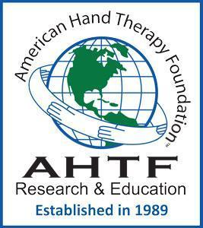 | The American Hand Therapy Foundation’s mission is to improve patient outcomes by promoting evidence-based practice through funding clinical and scientific research and education.  AHTF is committed to promoting a culture that respects all stakeholders involved in the delivery and research of upper extremity care.
The Ida M. Stern Research Education Scholarship
Introduction and eligibility:
The Ida M. Stern Research Education Scholarship was created through a generous donation from Ida M. Stern. The grant intends to promote research education in the field of hand and upper limb rehabilitation and, secondarily, to expand evidence-informed hand therapy services.
Any CHT in good standing pursuing additional research implementation skills through attendance in seminars, courses, or a post-professional degree program is eligible to apply.
Application Instructions
- Complete the application form below, including the required narrative essay justifying the need and/or the value of this funding for your research development. (see details below).
- Submit a current curriculum vitae (CV) that highlights your education, clinical practice employment or self-employment, publications and/or presentations, and service to the profession(s) of hand, physical, or occupational therapy.
- Two letters of reference should be submitted directly to the Director of Education by the deadline of July 1. The letters should address your current clinical, teaching, research, and/or service skills and convey your desire to improve your research skills and implement your research objectives.
- All materials , including this form, should be submitted as a single PDF document to the Director of Education at education@ahtf.org.

APPLICATION FORM
Name/credentials:
Address:

Contact information:

Email address: Phone:

CHT ID #: | ASHT #
Description of Continuing Education Activity: (A link may be added to the educational activity)
Sponsoring Organization (where the education will be received):
Attendance Dates:
Registration fee:
Description of Post-Professional Academic Education: (A link may be added to the educational institution)
Name of Institution:
Date of Admission:
Tuition:
Narrative justification: How will your attendance at this continuing education course or post-professional academic program contribute to your skill as a hand rehabilitation researcher and to the evidence supporting hand therapy interventions? (≤ 1,000 words).

