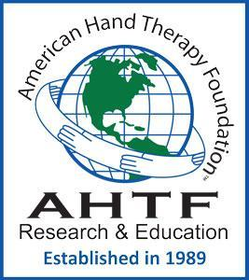 | The American Hand Therapy Foundation’s mission is to improve patient outcomes by promoting evidence-based practice through funding clinical and scientific research and education.  AHTF is committed to promoting a culture that respects diversity, inclusion, equity, and justice for all stakeholders involved in the delivery and research of upper extremity care.
The Ida M. Stern Research Education Scholarship
Introduction and eligibility:
The Ida M. Stern Research Education Scholarship was created through a generous donation from Ida M. Stern. The grant intends to promote research education in the field of hand and upper limb rehabilitation and, secondarily, to expand evidence-informed hand therapy services.
Any CHT in good standing pursuing additional research implementation skills through attendance in seminars, courses, or a post-professional degree program is eligible to apply.
Application Instructions
- Complete the application form below, including the required narrative essay justifying the need and/or the value of this funding for your research development. (see details below).
- Submit a current curriculum vitae (CV) that highlights your education, clinical practice employment or self-employment, publications and/or presentations, and service to the profession(s) of hand, physical, or occupational therapy.
- Two letters of reference should be submitted directly to the Director of Education by the deadline of July 1. The letters should address your current clinical, teaching, research, and/or service skills and convey your desire to improve your research skills and implement your research objectives.
- All materials , including this form, should be submitted as a single PDF document to the Director of Education, Caroline W Jansen, PT, PhD, CHT at education@ahtf.org.

APPLICATION FORM
Name/credentials:
Address:

Contact information:

Email address: Phone:

CHT ID #: | ASHT #
Description of Continuing Education Activity: (A link may be added to the educational activity)
Sponsoring Organization (where the education will be received):
Attendance Dates:
Registration fee:
Description of Post-Professional Academic Education: (A link may be added to the educational institution)
Name of Institution:
Date of Admission:
Tuition:
Narrative justification: How will your attendance at this continuing education course or post-professional academic program contribute to your skill as a hand rehabilitation researcher and to the evidence supporting hand therapy interventions? (≤ 1,000 words).

