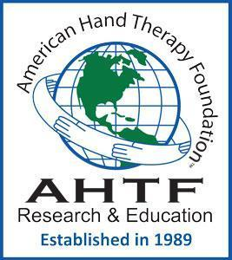 | The American Hand Therapy Foundation’s mission is to improve patient outcomes by promoting evidence-based practice through funding clinical and scientific research and education.  AHTF is committed to promoting a culture that respects diversity, inclusion, equity, and justice for all stakeholders involved in the delivery and research of upper extremity care.

Janet Albrecht Memorial Scholarship
Requirements and Responsibilities

Requirements:
1. Eligibility: Occupational Therapist (OT) or Physical Therapist (PT) in the process of pursuing the certification in hand therapy and/or a post-professional advanced degree (such as PhD, ScD etc.)
2. Complete the funded education/ course work within one calendar year of receipt of funds. No time extensions will be considered.
After Notification:
- Sign the Memorandum of Understanding (MOU) accepting the responsibilities associated with the award and return the signed agreement to the Education Director, Caroline W. Stegink- Jansen, PT, PhD, CHT at education@ahtf.org .
- Directly apply the grant funds to the expenses for which the scholarship is awarded.
Responsibilities:
4. Provide proof of completion of the funded experience to the Director of Education at education@ahtf.org.
5. Provide information of remaining funds to the Director of Education at education@ahtf.org and the AHTF Treasurer (contact information will be provided).
6. Remaining monies must be returned to the treasurer of the AHTF (contact information will be provided by the Education Division Director) within one year after the monies have been provided to the awardee.

Any questions or concerns? Contact the Director of Education Caroline W Jansen, PT, PhD, CHT at education@ahtf.org

