NEW in 2020:
Proposals focusing on “teletherapy” will be considered as offering new technology education

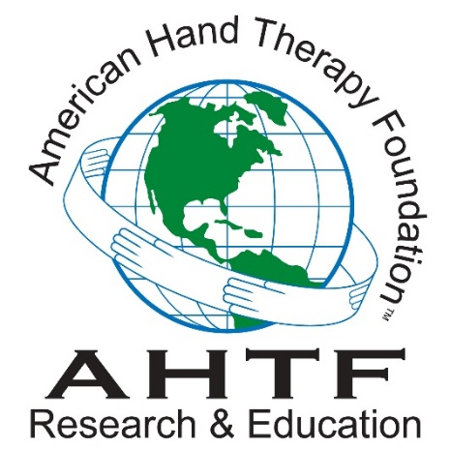

Application Form

Evelyn Mackin Grant for Education by a

Traveling Therapist
Established 2004

APPLICANT NAME:

Project Title:

FACILITY:

WORK ADDRESS:
STREET

CITY | STATE | ZIP CODE

PHONE | FAX

EMAIL ADDRESS

HOME ADDRESS:
STREET

CITY | STATE | ZIP CODE

PHONE | FAX

PERSONAL EMAIL ADDRESS

ASHT MEMBERSHIP #

CHT # | (if applicable)

YEAR GRADUATED FROM OT/PT SCHOOL

OT/PT LICENSURE/REGISTRATION # AND CURRENT STATUS OF LICENSURE

# OF YEARS WORKING IN A HAND THERAPY PRACTICE:

Personal or other contact information for dispersal of award (if awarded)

Signature Date

EDUCATIONAL ABSTRACT (up to 1/2 page):

PROPOSAL FOR EDUCATIONAL TRAVEL

(Not to exceed four pages of 12-point font type with one-inch margins all around)
Include the following information:

- Overall aims of the visit
  - Goals and objectives for the applicant (education provider)
    - Use SMART goal descriptions (Specific, Measurable, Attainable, Relevant, and Time-based goals)
  - Goals and objectives for the guest site (education recipient)

- Justification of the travel to complete the visit
  - A background description to justify the need and/or opportunities presented in the visit
  - Address why the travel is needed to meet the aims of the visit
  - Justify educator qualifications and the qualifications of the guest site to guide the visit to meet the goals and objectives

- Logistics of how to accomplish the stated goals
  - Travel plans
  - Plans for teaching and learning
  - Need for supplies if applicable
  - Sustainability of the acquired education/ supplies by the guest site
  - Specify the roles of the guest site and educator during the visit
  - Specify outcomes to document the results of the experience
  - Anticipated barriers or problems and plans to address them
  - Budget
  - Time line for the proposed activities
  - Plans to disseminate the results of experience for presentation at the annual meeting of the American Society of Hand Therapists or a peer- reviewed publication, preferably in the Journal of Hand Therapy

- Based on the tenet that those who provide and those who receive education all learn from the experience, indicate what the educator plans to learn from the guest site.

- Additional documentation
  - Support letters from guest site, preferably in the form of a Memorandum of Understanding, confirming the roles of the guest site and the educator during the visit

APPLICANT QUALIFICATIONS TO PROVIDE THE EDUCATION

Include a current curriculum vitae in the package submission

Provide evidence of active participation in the profession in the following areas:
TEACHING
1.
2.
FORMAL LEARNING (Inter-professional medical)
1.
2.
INDEPENDENT LEARNING (Inter-professional medical)
1.
2.
PUBLICATIONS
1.
2.
RESEARCH
1.
2.
GRANTS (grants writing and/or funding)
1.
2.
PROFESSIONAL VOLUNTEER SERVICE (International, National, State, Local)
1.
2.
RECEIVED AWARDS, SPECIAL RECOGNITION
1.
2.
DEVELOPING NEW PRODUCTS OR TREATMENT TECHNIQUES TO BENEFIT HAND THERAPY
1.
2.

NARRATIVE: Provide an explanation of the fit between the educator’s expertise, the planned education, and the knowledge gap to be addressed for the guest site (about ½ page)

Application for the Evelyn Mackin Grant for Education by a Traveling Therapist requires submission of a copy of the applicant’s curriculum vitae and a completed application form, both in PDF format. Two electronic copies of each document are required; one copy with the applicant’s identifying information and a second blinded copy (with no identifying information, e.g. name, institution, address).

Please submit these electronic copies to:

Director of Grants, April Cowan, OTR, OTD, CHT, at grants@ahtf.org
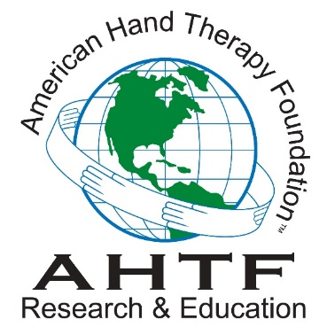

Rev. 1-3-2020

